## 1.1 Organization Background

Sift Co. is a technology company in Malaysia that focuses on e-commerce. Sift Co. business model is a hybrid of consumer-to-consumer marketplace and business-to-consumer. It partners with courier service providers to perform item pickup and delivery from its warehouse and sellers.

## 1.2 Organization Structure

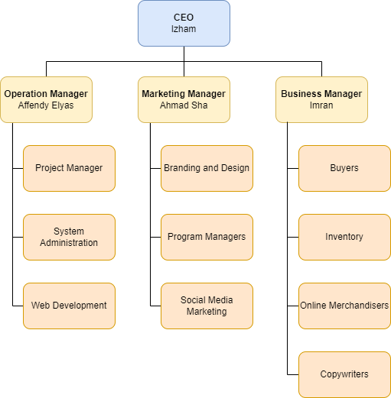

## 1.3 Network Architecture

## 1.4 Standard

ISO/IEC 27005:2008 Information Security Risk Management - enables us to acquire the necessary skills and knowledge to initiate the implementation of an information security risk management process. Therefore, it proves that you can identify, assess, analyze, evaluate and treat various information security risks faced by organizations. Moreover, it enables you to support organizations prioritize risks and undertake appropriate actions to reduce and mitigate them.